LECTURE 4
CLASSICAL ENCRYPTION

1. Classical Substitution Ciphers
In substitution ciphers, plaintext letters are replaced with other letters according to a rule.
The position of letters does not change — only the letters themselves are substituted.
Substitution ciphers can be:
- Monoalphabetic (one alphabet used)
- Polyalphabetic (multiple alphabets used)
- Polygram (groups of letters substituted together)

1.1 Polygram Ciphers
In polygram ciphers, multiple letters are encrypted together as a group instead of one letter at a time.
Why this is stronger:
- Letter frequency becomes less obvious.
- Instead of single-letter patterns, we get digraph (two-letter) patterns.
- Makes frequency analysis harder than monoalphabetic ciphers.
The most famous polygram cipher is:

1.1.1 Playfair Cipher
Playfair cipher encrypts plaintext in pairs of letters (digraphs).
Instead of substituting one letter, it substitutes two letters together using a 5×5 key matrix.
Playfair Key Matrix
A 5 × 5 matrix is created using a keyword.
Steps to Create the Matrix:
- Choose a keyword
Example: PLAYFAIR EXAMPLE
- Remove duplicate letters.
- Fill the matrix row-wise.
- Combine I and J (since 26 letters do not fit in 25 cells).
Final matrix from your image:
P L A Y F
I R E X M
B C D G H
K N O Q S
T U V W Z
Important:
- I and J are treated as the same letter.
- Only 25 cells are used.
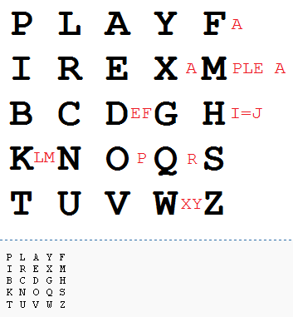
Encrypting and Decrypting
Plaintext is encrypted in pairs (digraphs).
Step 1: Prepare the Message
Message:
Hide the gold in the tree stump
Remove spaces and convert to uppercase:
HIDETHEGOLDINTHETREESTUMP
Break into digraphs:
HI DE TH EG OL DI NT HE TR EX ES TU MP
Note:
- If two letters in a pair are same (like EE in TREE), insert X.
- That is why TREE becomes TR EX ES.
Step 2: Apply Playfair Rules
There are three cases:
Case 1: Rectangle Rule (Most Common)
If letters form a rectangle:
- Replace each letter with the letter in same row but opposite corner column.
Example from your image: HI
H → (row 3, col 5)
I → (row 2, col 1)
Rectangle formed.
Replace with opposite corners:
B and M
So: HI → BM
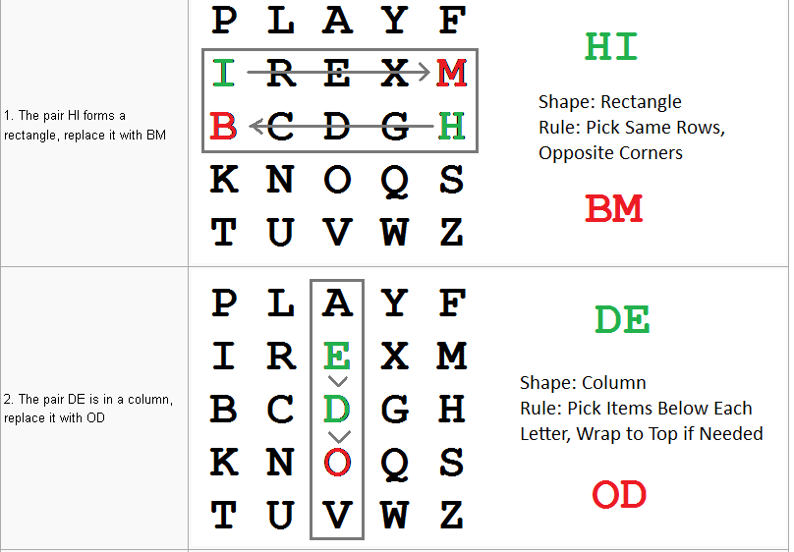
Case 2: Same Column Rule
If both letters are in same column:
- Replace each with letter below it.
- Wrap to top if needed.
Example: DE
D and E are in same column.
D → O
E → D
So: DE → OD
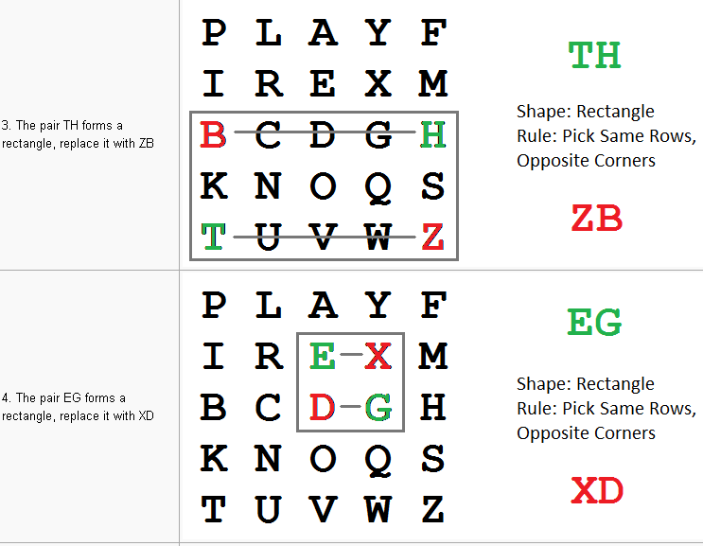
Case 3: Same Row Rule
If both letters are in same row:
- Replace each with letter to the right.
- Wrap to left if needed.
Example:
EX
E → X
X → M
So:
EX → XM
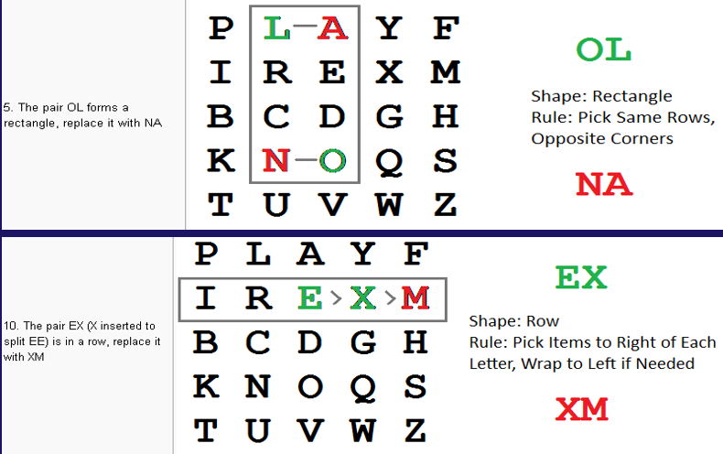
Applying All Rules to the Message
Digraphs:
HI → BM
DE → OD
TH → ZB
EG → XD
OL → NA
DI → BE
NT → KU
HE → DM
TR → UI
EX → XM
ES → MO
TU → UV
MP → IF
Final Ciphertext:
BMODZBXDNABEKUDMUIXMMOUVIF
Security of Playfair Cipher
Advantages:
- More secure than monoalphabetic substitution.
- Hides single-letter frequency.
- Works on digraph frequency.
- Was used in World War I and early World War II.
Weakness:
- Still preserves language structure.
- Digraph frequency analysis can break it.
- Not secure against modern cryptanalysis.
So it is stronger than simple substitution but not unbreakable.

2. Classical Transposition Ciphers
In transposition ciphers, letters are not changed.
Instead, their positions are rearranged.
Important:
- Substitution → changes letters
- Transposition → changes positions
Because letters remain same, frequency analysis can detect it more easily than substitution.

2.1 Rail Fence Cipher
Rail Fence is the simplest transposition cipher.
Concept
Plaintext is:
- Written diagonally across multiple rows (called rails)
- Then read row by row to produce ciphertext
The key is the depth (number of rails).
Working
Plaintext:
meet me after the party
Remove spaces:
meetmeaftertheparty
Write in zigzag (depth 2):
m |  | e |  | m |  | a |  | t |  | r |  | h |  | t |  | g |  | p |  | r |  | y
 | e |  | t |  | e |  | f |  | e |  | t |  | e |  | o |  | a |  | a |  | t

Now read row-wise:
Row 1 → MEMATRHTGPRY
Row 2 → ETEFETEOAAT
Ciphertext: MEMATRHTGPRYETEFETEOAAT
Important Points
- Key = number of rails
- More rails → more complex zigzag
- Decryption requires reconstructing zigzag pattern
Security
- Very weak cipher
- Easily broken by trying small rail depths
- Used mainly for learning purposes

2.2 Route Cipher
Route cipher is more complex than Rail Fence.
Instead of zigzag, plaintext is:
- Written in a grid (rectangle form)
- Read using a specific route (pattern)
The route is defined by the key.
Working
Plaintext is written in grid form:
Example grid:
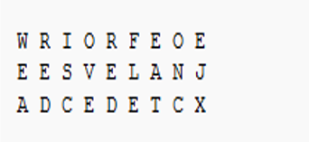
Now the key specifies a route.
Example route given:
“Spiral inwards, clockwise, starting from top right”
So instead of reading row-wise,
we follow the spiral pattern.
Resulting Ciphertext:
EXJCTEDECDAEWRIORFEONALEVSE
Important Points
- Key = grid dimensions + route pattern
- Many possible routes:
  - Spiral
  - Zigzag
  - Clockwise
  - Anti-clockwise
  - Column-wise
- More secure than Rail Fence because:
  - Large number of possible routes
Security
- Stronger than simple rail fence
- But still vulnerable to frequency analysis
- Poor route selection may leave visible patterns

2.3 Columnar Transposition Cipher
Columnar Transposition is a type of classical transposition cipher where:
- Letters are not changed
- Their positions are rearranged using a keyword
It is stronger than Rail Fence because it uses a key-based permutation.
Working Mechanism
The encryption process follows two main steps:
Step 1: Write Message Row-Wise
- Remove spaces and punctuation.
- Convert to uppercase.
- Write plaintext in rows under a keyword.
Example from slide:
Plaintext:
Attack Postponed until two am
Remove spaces:
ATTACKPOSTPONEDUNTILTWOAM
Step 2: Read Column-Wise in Specific Order
Columns are read in the order defined by the key.
This rearranges letter positions and produces ciphertext.
Key Ordering
Key can be given in two ways:
- Numeric key
Example: 4312567
- Alphabetic key
Example: DCABEFG
How Key Ordering Works
Take key: 4312567
Arrange numbers in ascending order:
1 2 3 4 5 6 7
Now check original positions:
Original: 4 3 1 2 5 6 7
Position of 1 → column 3
Position of 2 → column 4
Position of 3 → column 2
Position of 4 → column 1
Position of 5 → column 5
Position of 6 → column 6
Position of 7 → column 7
So reading order becomes:
3 → 4 → 2 → 1 → 5 → 6 → 7
That is the permutation.
If alphabetic key is used:
DCABEFG
Arrange alphabetically:
A B C D E F G
Match positions to get numeric order.

Example
Key:
4312567
Grid formed:
4 | 3 | 1 | 2 | 5 | 6 | 7
a | t | t | a | c | k | p
o | s | t | p | o | n | e
d | u | n | t | i | l | t
w | o | a | m | x | y | z
Now read columns according to ascending key order:
Column 1 (key=1 → column 3):
T T N A
Column 2 (key=2 → column 4):
A P T M
Column 3 (key=3 → column 2):
T S U O
Column 4 (key=4 → column 1):
A O D W
Column 5 (key=5 → column 5):
C O I X
Column 6 (key=6 → column 6):
K N L Y
Column 7 (key=7 → column 7):
P E T Z
Ciphertext:
TTNAAPTMTSUOAODWCOIXKNLYPETZ

2.4 Grille Cipher
Grille is a classical transposition cipher.
It uses a physical template (called a grille) with holes cut in specific positions.
Instead of rearranging letters after writing,
letters are written only in the visible holes, and the grille is rotated.

Basic Idea
A grille is:
- A square sheet (usually 4×4, 5×5, 6×6, etc.)
- Some squares are cut out (holes)
- When placed over blank paper, only hole positions are visible
Plaintext letters are written only in those holes.
Then the grille is rotated 90° and writing continues.
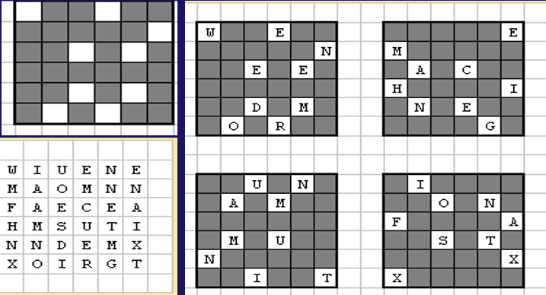
Working Mechanism
Step 1: Choose Grid Size
In your slide example, it appears to be a 6 × 6 grid.
That means total 36 positions.
Step 2: Prepare Plaintext
Given in slide:
We need more machine gun ammunition fast xx
Remove spaces:
WENEEDMOREMACHINEGUNAMMUNITIONFASTXX
If needed, add filler letters so total letters = 36.
Step 3: Place Grille (0° Position)
Place grille on blank grid.
Write letters of plaintext in visible holes only.
After filling those holes → rotate grille 90° clockwise.
Step 4: Rotate 90°
Write next set of letters in new visible holes.
Step 5: Rotate 180°
Write next letters.
Step 6: Rotate 270°
Write final letters.
After four rotations:
All grid positions are filled.
Important rule:
✔ No hole should overlap another hole during rotations.
✔ Every cell must be used exactly once.

Final Ciphertext
After grid is completely filled,
read the entire grid row-wise to produce ciphertext.
From your slide (bottom-left grid):
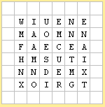
Reading row-wise gives ciphertext:
WIUENEMAOMNNFAECEAHMSUTINNDEMXOIRGT
Key in Grille Cipher
The key consists of:
- Grid size
- Hole positions
- Rotation direction (usually clockwise)
Unlike columnar cipher:
There is no keyword.
The physical hole pattern is the key.
Why Grille Is Stronger Than Simple Transposition
- Large number of possible hole patterns
- Rotation increases complexity
- Hard to guess hole positions without key
Weakness
- If grille pattern is discovered, cipher is easy to break.
- Poorly designed grille may cause overlapping holes.

3. Classical Product Ciphers and Fractioning Systems
This topic combines substitution and transposition to increase security.
The main idea:
Single substitution → weak
Single transposition → weak
But combining them → much stronger

3.1 Product Cipher
Definition
A Product Cipher is formed by applying more than one encryption operation, usually:
Substitution + Transposition
Important concept:
- Two substitutions = still just a substitution
- Two transpositions = still just a transposition
- But substitution followed by transposition = much stronger cipher
Because:
Substitution changes letters
Transposition changes positions
So structure + frequency are both hidden.
Why It Is Stronger
Substitution hides letter identity.
Transposition hides letter position.
Together, they:
- Flatten frequency patterns
- Destroy language structure
- Increase key complexity
Modern block ciphers (like AES) are actually advanced product ciphers.
Simple Conceptual Example
Step 1: Apply substitution
HELLO → IFMMP
Step 2: Apply transposition
IFMMP → MFIPM
Now breaking becomes harder because:
You must undo both steps in correct order.

3.2 Fractioning Systems
Fractioning is a special type of substitution.
Instead of replacing a letter with one letter,
it replaces a letter with multiple symbols.
Example:
A → 11
B → 12
C → 13
So each letter is broken into parts.
That is why it is called fractionation.
How Fractioning Works
Step 1:
Convert plaintext letters into coordinate pairs.
Step 2:
Apply transposition to those coordinates.
This spreads parts of one letter far apart in ciphertext.
Why Fractioning Is Powerful
Suppose:
A → 11
After transposition:
First 1 goes somewhere,
Second 1 goes somewhere else.
Now original letter pattern is completely hidden.
This destroys digraph and trigram patterns.
Common Fractioning Systems
- Polybius Square
- ADFGX Cipher
- ADFGVX Cipher
- Bifid Cipher
- Trifid Cipher
All combine substitution (fractioning) + transposition.
Difference Between Product Cipher and Fractioning
Product Cipher:
General term for combining substitution + transposition.
Fractioning:
Special substitution method where letters are split into parts before transposition.
So:
Fractioning ⊂ Product Cipher
(All fractioning systems are product ciphers, but not all product ciphers use fractioning.)

3.2.1 Polybius Square
Polybius Square is a fractioning substitution system.
Each plaintext letter is replaced by its row and column coordinates in a 5 × 5 grid.
Because 26 letters do not fit in 25 cells,
I and J are combined.
Standard 5 × 5 Grid (From Your Slide)
Columns: 1 2 3 4 5
Rows: 1 2 3 4 5
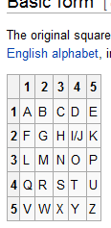
Working Mechanism
Each letter → replaced with two digits:
First digit = Row
Second digit = Column
Example
Plaintext:
BAT
B → Row 1, Column 2 → 12
A → Row 1, Column 1 → 11
T → Row 4, Column 4 → 44
Ciphertext:
12 11 44
Why It Is Called Fractioning
Each letter is broken into two parts (coordinates).
So:
A → 11
Instead of one symbol, we get two.
This allows further transposition for stronger encryption.

3.2.2 ADFGX Cipher
ADFGX is a Product Cipher that combines:
- Polybius square (fractionation)
- Columnar transposition
It was used by Germany in World War I.
The name comes from the five letters used:
A, D, F, G, X
These letters represent row and column labels.
Fractionation Stage (Stage 1)
Instead of numbers 1–5, rows and columns are labeled: A D F G X
Example grid:
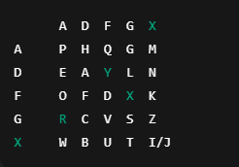
How Fractionation Works
Suppose plaintext:
ATTACK
Find coordinates:
A → D D
T → X G
T → X G
A → D D
C → G D
K → F X
Fractionated form:
DD XG XG DD GD FX
Remove spaces:
DDXGXGDDGDFX
Now letters are only from {A, D, F, G, X}.
Columnar Transposition Stage (Stage 2)
Now apply columnar transposition on the fractionated text.
Choose keyword:
CARGO
Write text row-wise under keyword:
C A R G O
D D X G X
G D D G D
F X
(Continue filling row-wise)
Now rearrange columns alphabetically by key:
A C G O R
Reorder columns accordingly.
Read column-wise to get final ciphertext.
Example (Conceptual Summary)
Plaintext:
ATTACK
Step 1: Polybius fractionation
→ DDXGXGDDGDFX
Step 2: Columnar transposition
→ Final ciphertext (after column reading)
Result: Ciphertext contains only A, D, F, G, X.
Why ADFGX Is Stronger
Polybius:
Breaks letters into coordinate pairs.
Transposition:
Shuffles those pairs.
So:
- Frequency of letters is hidden.
- Digraph patterns are destroyed.
- Harder to break than simple substitution.
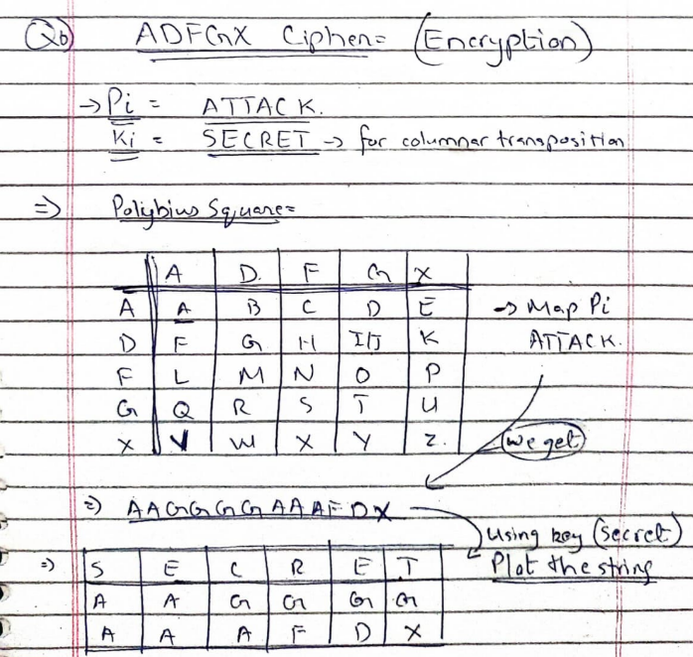
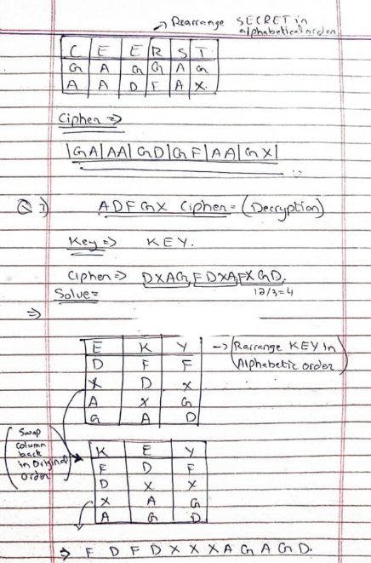
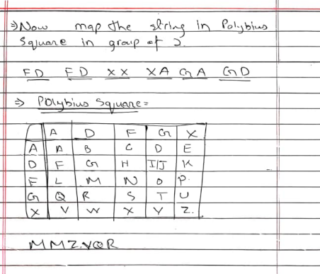

3.2.3 Bifid Cipher
The Bifid Cipher is a classical fractionation cipher that combines:
- Polybius Square substitution
- Transposition of coordinates
It was invented by Félix Delastelle in 1901.
It is a product cipher because it combines substitution and transposition.
Basic Idea
In Polybius square:
Each letter → replaced by row and column numbers.
In Bifid:
- Convert letters to coordinates.
- Separate row numbers and column numbers.
- Rearrange them.
- Convert back to letters.
This mixing step increases security.
Step 1: Mixed Alphabet Polybius Square
From your image, the square is:
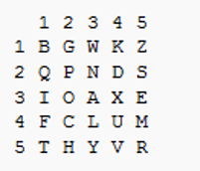
This is a mixed alphabet square, not standard alphabetical order.
Step 2: Plaintext
F L E E A T O N C E
Step 3: Convert to Coordinates
Find each letter’s row and column.
Letter | Row | Column
F | 4 | 1
L | 4 | 3
E | 3 | 5
E | 3 | 5
A | 3 | 3
T | 5 | 1
O | 3 | 2
N | 2 | 3
C | 4 | 2
E | 3 | 5

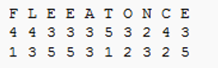

So, we write vertically:
Rows: 4 4 3 3 3 5 3 2 4 3
Columns: 1 3 5 5 3 1 2 3 2 5
Step 4: Read in Rows (Combine)
Write all row numbers first, then all column numbers:
4 4 3 3 3 5 3 2 4 3 1 3 5 5 3 1 2 3 2 5
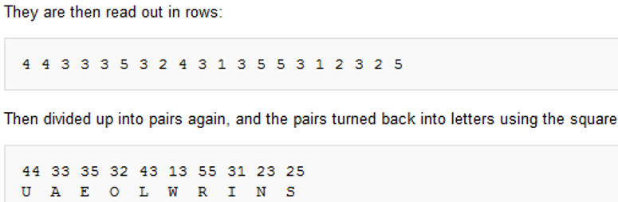
Step 5: Divide into Pairs
Group into pairs:
44 33 35 32 43 13 55 31 23 25
Step 6: Convert Back to Letters
Using the same square:
44 → U
33 → A
35 → E
32 → O
43 → L
13 → W
55 → R
31 → I
23 → N
25 → S
Final Ciphertext
U A E O L W R I N S

What Is Happening Technically?
In Bifid:
- Letters → coordinates
- Coordinates are split into row and column groups
- They are recombined differently
- Then converted back
So, it mixes substitution + transposition inside the coordinates.
That is why it is a product cipher.

